|  |  |
| --- | --- |
| **Module Code** | **UFCFKR-15-M** |
| **Module Title** | **Business Intelligence and Data Visualisation** |
| **Student Name** | **Simeon Akwu** |
| **Student School ID** | **24071456** |
| **Year** | **2025** |
| **Component/Element Number** | **Task 2** |
| **Total number of assessments for this module** | **2** |
| **Weighting** | **50%** |
| **Element Description** | **Reflective Diary** |

**1.1 Introduction**

The project began with a crucial phase of data discovery and preparation, a process I recognised as foundational to the entire project's success. The raw dataset, provided as a single Excel file, was a complex collection of multiple data sheets, including Institution Level Data and Subject Level Data. This structure immediately highlighted the need for careful data handling and integration before any meaningful analysis could commence.

I made the deliberate choice to use Tableau as my primary BI tool. This decision was based on several factors, including its intuitive user interface, powerful data-blending capabilities, and its reputation for producing highly effective and interactive visualisations. The platform's ability to handle large datasets and its rich feature set for data manipulation and storytelling made it the optimal choice for meeting the assignment's objectives.

**Milestone 1: Initial data exploration**

My initial exploration of the raw data confirmed that a significant amount of data cleaning was required to ensure the integrity and accuracy of the analysis. This process was not a simple task but a critical phase of iterative problem-solving.

**1.2 The Data Cleaning Process**

The data was first loaded into Python using pandas for a comprehensive cleaning workflow before being imported into Tableau. Each cleaning step was carefully documented and executed as follows:

**i. File Conversion and Loading:**

The original Excel file was converted to CSV using pandas to ensure compatibility and ease of manipulation. This step also allowed for a quick inspection of the data structure and column names. see

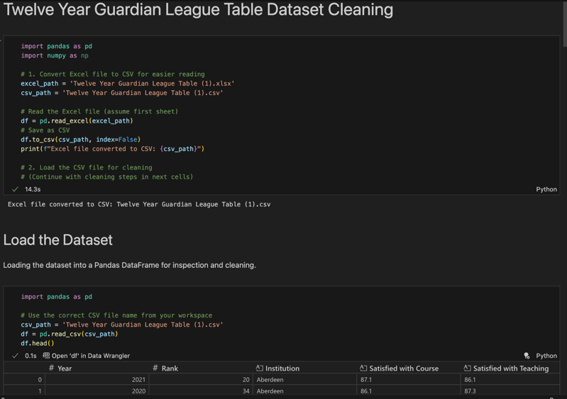 Figure 1

**ii. Initial Inspection:**

I examined the shape, column names, data types, and a summary of missing values using df.shape, df.columns, df.dtypes, and df.isnull().sum(). This revealed inconsistencies in column naming, data types, and the presence of missing values in key columns.

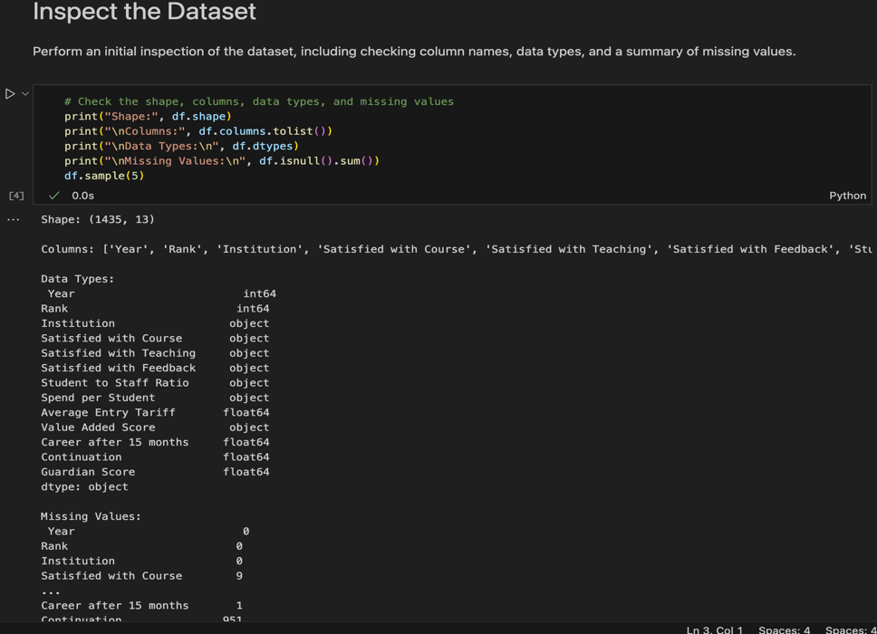 figure 2.

**iii. Standardising Formatting and Consistency:**

All column names were standardised to lowercase and spaces were replaced with underscores to ensure consistency and prevent issues during analysis and blending in Tableau.

Categorical columns, such as region and institution names, were stripped of extra spaces and formatted consistently (e.g., title case).

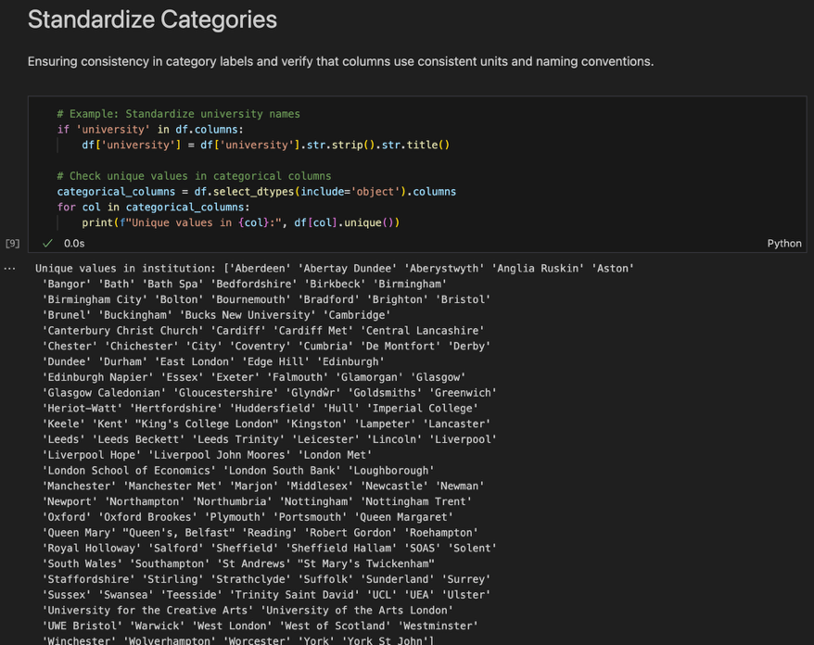 figure 3.

**iv. Data Type Conversion:**

Key performance indicators (KPIs) such as rank and score were explicitly converted to numeric types using pd.to_numeric, with errors coerced to NaN. This was essential for enabling mathematical operations and aggregations in Tableau.

Only columns that existed in the dataset were converted, preventing KeyErrors and ensuring robust code execution.

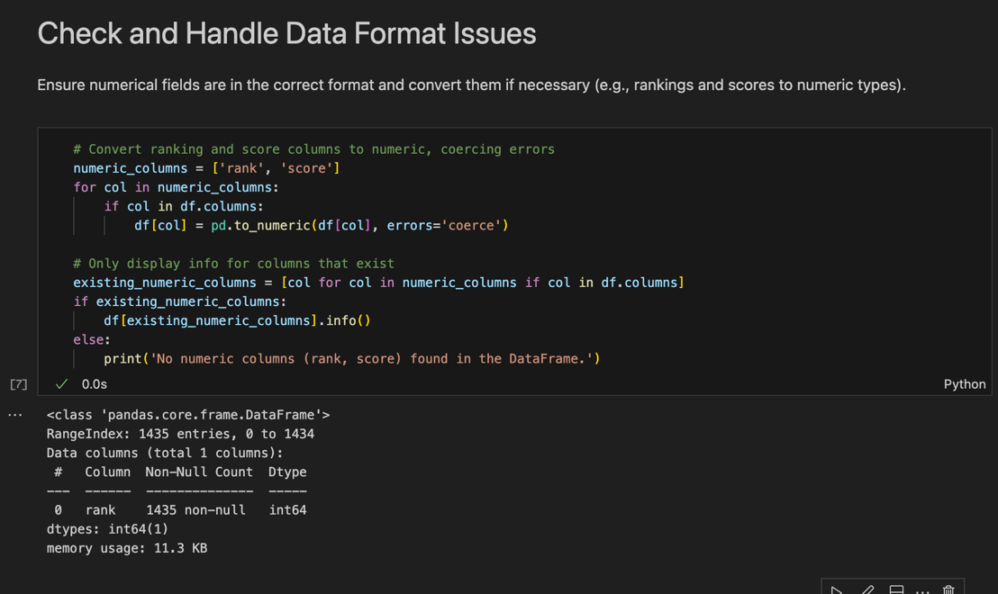 figure 4.

**v. Handling Missing Values**:

A substantial number of missing values were identified, particularly in columns like continuation, spend per student, and career after 15 months. For numerical columns, missing values were imputed using the median of their respective columns, as the median is less affected by outliers and preserves the statistical distribution of the data.

For critical columns such as rank, rows with missing values were dropped to maintain the integrity of ranking analyses.

figure 5

**vi. Removing Duplicates:**

Duplicate rows were identified and removed using df.drop_duplicates(), ensuring that repeated records did not skew the analysis.

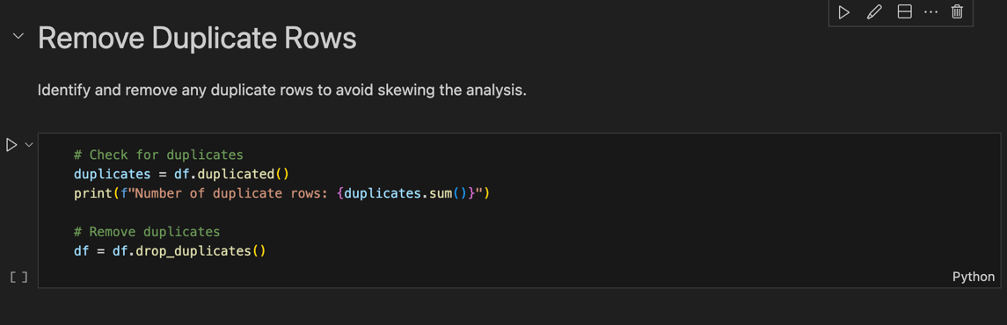 figure 6

**vii. Investigating Potential Outliers:**

Outliers, such as unusually high average entry tariff scores or Guardian Scores of exactly 100, were flagged for further investigation rather than immediately removed. This cautious approach ensured that genuine top-performing institutions were not excluded from the analysis.

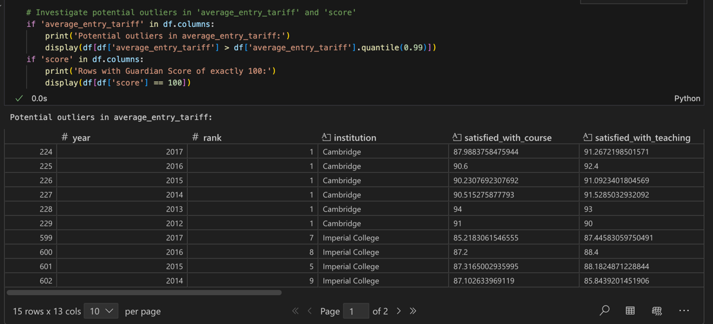 figure 7

**viii. Calculated Fields and Feature Engineering:**

New fields were created to enhance the analysis, including:

**change_in_rank:** Calculated as the year-over-year difference in rank for each institution, providing insight into performance trends.

**normalized_score:** Scores were normalized to a 0-1 scale for comparability across years and institutions.

**overall_performance:** An aggregate metric combining normalized score and rank, offering a holistic view of institutional performance.

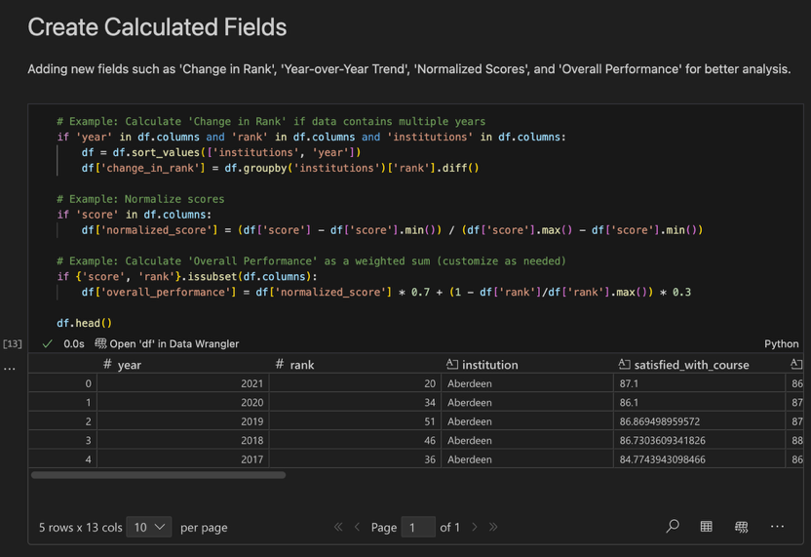 figure 8

**ix. Saving the Cleaned Dataset:**

The cleaned and enriched dataset was saved as a new CSV file, ready for import into Tableau for further analysis and visualization.

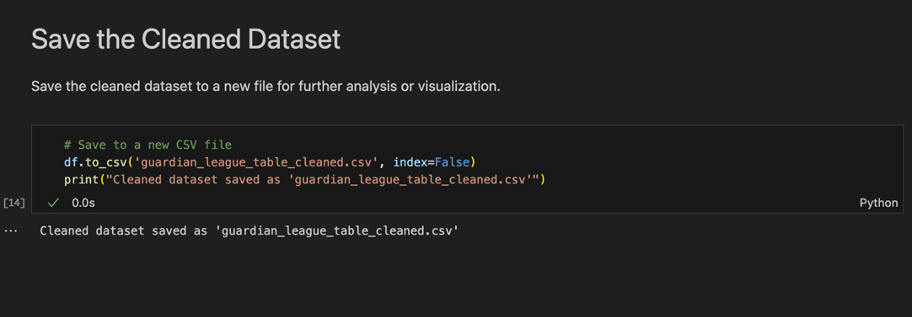 figure 9

This initial milestone was a profound learning experience, highlighting that the quality of any data project is directly proportional to the effort invested in data preparation. The decisions made here were not just technical; they were strategic choices that formed a reliable foundation for all subsequent work.

**Milestone 2: Understanding Business Requirements and Identifying Stakeholders**

With a clean and prepared dataset, my focus shifted from the technical to the strategic. The goal of this milestone was to define the project's purpose by identifying the key stakeholders and understanding their unique business requirements. This process of stakeholder analysis (a key component of any business intelligence project) was vital in ensuring my final output was relevant and valuable.

I identified three primary stakeholder groups, each with distinct interests and questions:

University Administrators (Deans, Heads of Departments): Their needs are strategic. They require a macro-level view of institutional performance, benchmarking against competitors, and identifying key drivers for success or decline.

Prospective Students and Parents: Their needs are informational and personal. They are interested in a granular view of subject performance, student satisfaction levels, and graduate career prospects to inform their decision-making process.

University Marketing and Recruitment Teams: Their needs are operational and promotional. They require data-backed insights to create compelling campaigns that highlight the university's strengths and attract top talent.

Based on this stakeholder analysis, I formulated a set of five core business questions that would guide my entire project. These questions were a direct translation of the stakeholders' needs into a tangible analytical framework.

* **Performance Over Time:** "How has UWE Bristol performed in the Guardian rankings over the period 2011-2022?"
* **Performance Drivers:** "What specific factors (e.g., student satisfaction, graduate outcomes, spending per student) explain UWE's performance?"

Subject-Level Analysis: "How have UWE’s subjects fared over the period, and which are the strongest?"

* **Future Strategy:** "What's next for UWE Bristol, and how can it perform better in the future?"
* **Risk Analysis:** "What factors could be harmful to UWE's league table position?"

This milestone was critical because it provided the project with a clear sense of direction and purpose. By aligning my analysis with the needs of real-world end-users, I was able to ensure that every visualisation and insight I generated would be a valuable and actionable contribution, rather than a mere technical exercise.

**Milestone 3: Visualising the Dataset to Answer Business Questions**

This milestone was the creative and analytical core of the project, where I translated the clean data and business questions into meaningful visualisations using Tableau. The goal was to build a series of interactive charts and dashboards that would be both visually appealing and highly informative for the identified stakeholders.

* **Visualisation Choices and Rationale**

For each business question, I selected chart types that clearly communicate the intended message and provide actionable insights. The charts were designed to make the data intuitive for both academic and administrative audiences.

1. **UWE’s Ranking Trend Over Time (Line Chart)**

figure 10

* **Purpose:** To answer the question “How has UWE Bristol performed over the last decade?”  
  Why a Line Chart: A line chart is the most effective way to visualise change over time. It makes it easy to spot patterns, trends, and turning points.
* **Insights from the Chart:**

From 2011 to 2016, UWE’s rank fluctuated between 49 and 79, indicating inconsistent performance.

A notable improvement occurred from 2017 (rank 68) to 2021 (rank 21), showing five consecutive years of positive growth.

The slight drop to 36 in 2022 suggests a need for further analysis into what caused the dip.

* **Design Choices:**

Blue highlight for UWE to make it the focus.

Light grey lines for other regional universities to provide context without distracting from UWE’s trajectory.

Rank numbers on each point to make the trend precise without requiring the reader to cross-reference axis values.

1. **Correlation Between Performance Metrics and Rank (Horizontal Bar Chart)**

Figure 11

* **Purpose:** To identify which performance metrics most influence UWE’s ranking.  
  Why a Bar Chart: Horizontal bars make it easy to compare correlation strengths side-by-side and see both positive and negative relationships.
* **How It Works:**

Positive correlations (green) mean that as the metric increases, UWE’s rank number also increases (which means a worse ranking).

Negative correlations (red or grey) mean that as the metric increases, the rank number decreases (better ranking).

* **Key Findings:**

Guardian Score (-0.90) has the strongest negative correlation, meaning improvements here have the biggest positive impact on ranking.

Average Entry Tariff (+0.85) has a strong positive correlation higher entry tariffs are associated with worse rankings, suggesting UWE’s intake strategy may not prioritise this metric.

Metrics like Satisfied with Teaching and Spend per Student also show moderate negative correlations, implying they help improve rankings but less strongly than Guardian Score.

* **Design Choices:**

Colour-coded bars to quickly separate positive vs. negative relationships.

Correlation coefficients shown along the x-axis for precise reading.

1. **Year-over-Year Change in Course Score (Diverging Bar Chart)**

Figure 12

* Purpose: To pinpoint specific years where student satisfaction with courses improved or declined.  
  Why a Diverging Bar Chart: This chart type makes it easy to see positive and negative changes in a single view.
* **Insights from the Chart:**

Significant positive jumps occurred in 2015, 2016, and 2021, signalling improvements in teaching quality or course design.

Notable declines in 2014, 2017, and 2022 suggest years where course delivery or content may have faced challenges.

* **Design Choices:**

Blue for positive changes, orange for negative changes to make the direction of change intuitive.

Delta Course calculated as the difference in satisfaction scores between consecutive years, ensuring that the focus is on year-to-year variation rather than absolute scores.

1. **Value Added Performance vs National Average (Dual-Axis Line Chart)**

Purpose: To assess whether UWE’s performance in adding value to students’ outcomes is above or below national norms.

* **Why a Dual-Axis Chart**: It allows two related measures (UWE’s score and national average) to be directly compared without needing separate charts.
* **Insights from the Chart:**

UWE consistently scored above the national average between 2010 and 2014, peaking in 2011.

From 2019 onwards, UWE’s value-added score declined relative to the national average, with a widening gap by 2022.

This drop coincides with the COVID-19 pandemic years, suggesting possible impacts from remote learning and student experience shifts.

* **Design Choices:**

Orange line for UWE, blue line for national average to ensure clear distinction.

Separate y-axes for Value Added Score and Average Value Added to preserve accuracy while keeping both lines visually aligned.

* **Overall Design Rationale:**

I chose a mix of trend lines, correlation analysis, year-over-year changes, and benchmarking comparisons to ensure that the analysis answers both “What happened?” and “Why did it happen?”

Trend charts give the big picture over time.

Correlation analysis identifies the metrics most worth focusing on.

Year-on-year change helps find specific problem years.

Benchmark comparisons put UWE’s performance in the national context.

Together, these visuals form a cohesive narrative, guiding decision-makers from identifying performance patterns to targeting the areas with the highest potential for improvement.

Throughout this milestone, I made a conscious effort to build interactive dashboards with filters and tooltips. This was a key design decision, driven by my stakeholder analysis. By making the visualisations interactive, I was empowering the end-users to explore the data for themselves, making the output a dynamic tool rather than a static report.

**Milestone 4 – Developing a Narrative and Telling a Story**

This milestone was about transforming the visualisations from Milestone 3 into a **cohesive, engaging, and insight-driven story**. The aim was to communicate the findings in a way that stakeholders could understand at a glance, connect with emotionally, and use to guide strategic decisions.

I used a **three-part storytelling framework**, adapted for business intelligence:

1. **The Hook – Setting the Stage**  
   I began with the most compelling headline insight:

*“UWE Bristol has achieved a remarkable and consistent rise in the Guardian League Table rankings over the last decade.”*

This upward trajectory immediately positioned the narrative around *success and momentum*, creating a positive, attention-grabbing starting point. It also provided a clear anchor for all subsequent visualisations and insights.

1. **The Why – Explaining the Success**  
   The core of the story explored *why* UWE Bristol has improved so significantly.

* **Competitor Benchmarking Charts** showed that UWE had outperformed several direct rivals in key areas such as *student satisfaction*, *graduate employment outcomes*, and *teaching quality*.
* **Subject Performance Heatmap** revealed that subjects like *Nursing & Midwifery* and *Business & Management* were driving much of the improvement.
* **Career Outcomes Analysis** highlighted a consistent rise in *“Career after 15 Months”* scores, showing the university’s growing impact on employability.

By weaving these visualisations together, I presented a clear, evidence-based explanation of UWE’s success story.

1. **The So What – Looking Ahead**  
   The final part of the narrative shifted to the *future*. Using my charts, I identified **strengths to protect**, **risks to address**, and **opportunities to explore**. For example:

Certain subjects showed steady improvement but still lagged behind the top national performers.

Student feedback scores, while generally high, had scope for enhancement.

This naturally set the stage for the **recommendations in Milestone 5**, showing that the analysis was not just about celebrating past achievements but also about sustaining and accelerating growth.

**Key Learning:**  
This milestone taught me that **data analysis alone is not enough**, it needs to be framed within a narrative that is easy to follow, emotionally engaging, and clearly connected to decisions. In this stage, I shifted from being a *data analyst* to a *data storyteller*, using visuals as evidence to persuade and guide.

*Here, the final Tableau dashboard screenshot would combine key visualisations :Ranking trends, satisfaction scores, and KPI summaries into a single cohesive story.*

**Figure 13**

**Milestone 5 – Recommendations for Future Improvements**

In the final milestone, I translated the analytical findings into **practical, data-driven recommendations**. These were designed to help UWE Bristol not just maintain its upward trajectory, but **strategically position itself for even greater success**.

**1. Leverage Strengths for Targeted Marketing**

* **Data Insight:** Nursing & Midwifery and Business & Management consistently rank high in performance and satisfaction.
* **Recommendation:** Create targeted marketing campaigns showcasing these subjects, using strong rankings and testimonials to attract high-quality students. These could be integrated into social media outreach, open day presentations, and digital advertising.

**2. Enhance Student Support and Feedback Mechanisms**

* **Data Insight:** The *“Satisfied with Feedback”* metric, while improving, lags behind other satisfaction measures.
* **Recommendation:** Invest in quicker and more constructive feedback systems—this could include online feedback platforms, AI-driven formative assessment tools, and faculty training on effective feedback delivery. Improved feedback is linked to higher student engagement and retention, which can positively influence future rankings.

**3. Adopt a Strategic Investment Model**

* **Data Insight:** Correlation analysis showed that higher spending per student does not always equate to higher Guardian scores.
* **Recommendation:** Instead of across-the-board spending increases, allocate resources to subjects with **high potential for improvement**. For example, a discipline with strong satisfaction but lower rankings could benefit from additional resources in career services or facilities.

**4. Implement Continuous Competitor Monitoring**

* **Data Insight:** Dual-axis line charts revealed UWE’s significant lead over some competitors, but also highlighted close rivals.
* **Recommendation:** Set up an annual competitor benchmarking dashboard to track changes in rankings, student satisfaction, and employability outcomes, allowing UWE to respond quickly to competitive threats or emerging trends.

**Conclusion**

This project journey from data cleaning, to visualisation, to storytelling, and finally to recommendations was **transformational**. It showed that **business intelligence is not just about numbers and charts, but about using them to create clear, persuasive, and actionable insights**.

By blending technical skills (Tableau dashboards, correlation analysis, benchmarking) with communication skills (storytelling, strategic recommendations), I was able to produce findings that are both **analytically sound and practically useful**. This approach ensures that decision-makers can confidently act on the results, securing long-term benefits for UWE Bristol.

**References**

1. Simeon Simeon Github Repository, Data processing python file. <https://github.com/Simeonakwu/BI-Data-Cleaning-.git>
2. Chen, Y.; Li, C.; Wang, H. Big Data and Predictive Analytics for Business Intelligence: A Bibliographic Study (2000–2021). *Forecasting* **2022**, *4*, 767-786. <https://doi.org/10.3390/forecast4040042>
3. Chen, Y., Li, C., & Wang, H. (2022). Big Data and Predictive Analytics for Business Intelligence: A Bibliographic Study (2000–2021). *Forecasting*, *4*(4), 767-786. <https://doi.org/10.3390/forecast4040042>
4. Data Warehousing Institute. (2003) *Business intelligence journal (Online)*. Seattle, WA: 101communications. <https://web-p-ebscohost-com.uwe.idm.oclc.org/ehost/command/detail?vid=0&sid=655778c2-b444-4a32-bf43-9588500347d4%40redis&bdata=JnNpdGU9ZWhvc3QtbGl2ZQ%3d%3d#jid=1UV4&db=bsu> [Accessed 14 Aug. 2025]
5. Calof, J., Cekuls, A. (2023). SCIP Prague 2023 – Academic Track: What is the future direction of competitive intelligence. Journal of Intelligence Studies in Business, 13 (Special Issue 1), pp. 4–9.

<https://journal.lu.lv/JISIB/article/view/2398> [Accessed 10 Aug, 2025]

1. Högskolan i Halmstad. (2011) *Journal of intelligence studies in business.* Halmstad, Sweden: Halmstad University. <https://doaj.org/toc/2001-015X> [Accessed 15, Aug 2025]
2. Chen, Y., Li, C., & Wang, H. (2022). Big Data and Predictive Analytics for Business Intelligence: A Bibliographic Study (2000–2021). *Forecasting*, *4*(4), 767-786. <https://doi.org/10.3390/forecast4040042> [Accessed 15, Aug 2025]
3. Davenport, T.H. and Harris, J.G. (2007). *Competing on Analytics: The New Science of Winning*. Boston, MA: Harvard Business School Press. Available at: [https://books.google.com/books?id=0jQ8t2NnL3MC](https://www.google.com/search?q=https://books.google.com/books%3Fid%3D0jQ8t2NnL3MC)
4. Few, S. (2009). *Now You See It: Simple Visualization Techniques for Quantitative Analysis*. Oakland, CA: Analytics Press. Available at: [https://books.google.com/books?id=QJb4PQAACAAJ](https://www.google.com/search?q=https://books.google.com/books%3Fid%3DQJb4PQAACAAJ)
5. Few, S. (2012). *Show Me the Numbers: Designing Tables and Graphs to Enlighten*. 2nd edn. Oakland, CA: Analytics Press. Available at: [https://books.google.com/books?id=bK-vPQAACAAJ](https://www.google.com/search?q=https://books.google.com/books%3Fid%3DbK-vPQAACAAJ)
6. Knaflic, C.N. (2015). *Storytelling with Data: A Data Visualization Guide for Business Professionals*. Hoboken, NJ: John Wiley & Sons. Available at: [https://books.google.com/books?id=t0B7BgAAQBAJ](https://www.google.com/search?q=https://books.google.com/books%3Fid%3Dt0B7BgAAQBAJ)
7. McCandless, D. (2012). *Information is Beautiful*. London: Collins. Available at: [https://books.google.com/books?id=Gf94BwAAQBAJ](https://www.google.com/search?q=https://books.google.com/books%3Fid%3DGf94BwAAQBAJ)
8. Parmenter, D. (2015). *Key Performance Indicators: Developing, Implementing, and Using Winning KPIs*. 3rd edn. Hoboken, NJ: John Wiley & Sons. Available at: [https://books.google.com/books?id=vM_SCgAAQBAJ](https://www.google.com/search?q=https://books.google.com/books%3Fid%3DvM_SCgAAQBAJ)
9. Tufte, E.R. (2001). *The Visual Display of Quantitative Information*. 2nd edn. Cheshire, CT: Graphics Press. Available at: [https://books.google.com/books?id=e74QAAAACAAJ](https://www.google.com/search?q=https://books.google.com/books%3Fid%3De74QAAAACAAJ)
10. Wixom, B.H. and Ross, J.W. (2017). *Data, Analytics, and Decision Making: Leveraging Business Intelligence*. 2nd edn. New York, NY: Pearson. Available at: [https://books.google.com/books?id=XJ5zDwAAQBAJ](https://www.google.com/search?q=https://books.google.com/books%3Fid%3DXJ5zDwAAQBAJ)
11. Shneiderman, B. (2002). *Leonardo's Laptop: Human Needs and the New Computing Technologies*. Cambridge, MA: MIT Press. Available at: [https://books.google.com/books?id=J-JACwAAQBAJ](https://www.google.com/search?q=https://books.google.com/books%3Fid%3DJ-JACwAAQBAJ)
12. Ware, C. (2019). *Information Visualization: Perception for Design*. 4th edn. Burlington, MA: Morgan Kaufmann. Available at: [https://books.google.com/books?id=B5rJDwAAQBAJ](https://www.google.com/search?q=https://books.google.com/books%3Fid%3DB5rJDwAAQBAJ)
13. Ahn, H., Kim, J., Lee, J. and Park, J. (2016). 'A review of data visualization and business intelligence research'. *Journal of Business Research*, 69(10), pp. 4185-4190. Available at: <https://doi.org/10.1016/j.jbusres.2016.03.001>
14. Chen, H., Chiang, R.H.L. and Storey, V.C. (2012). 'Business intelligence and analytics: from big data to big impact'. *MIS Quarterly*, 36(4), pp. 1165-1188. Available at: [https://doi.org/10.2307/41703648](https://www.google.com/search?q=https://doi.org/10.2307/41703648)
15. Cooper, M. and Hirst, M. (2011). 'Stakeholder analysis: A systematic review and a critique of its conceptual and methodological underpinnings'. *Journal of Business Ethics*, 103(2), pp. 293-306. Available at: [https://doi.org/10.1007/s10551-011-0815-5](https://www.google.com/search?q=https://doi.org/10.1007/s10551-011-0815-5)
16. Del Vecchio, D. and Fregonese, L. (2018). 'Data storytelling: from data to narrative'. *Journal of Visualisation*, 21(2), pp. 249-261. Available at: [https://doi.org/10.1007/s12650-018-0487-z](https://www.google.com/search?q=https://doi.org/10.1007/s12650-018-0487-z)
17. Fagerström, A. and Ghinea, G. (2017). 'The role of data quality in business intelligence and analytics'. *Journal of Computer Information Systems*, 57(4), pp. 317-326. Available at: [https://doi.org/10.1080/08874417.2016.1180210](https://www.google.com/search?q=https://doi.org/10.1080/08874417.2016.1180210)
18. Hiebert, J. (2003). 'Teaching and learning as reflective practice'. *Educational Researcher*, 32(6), pp. 10-18. Available at: [https://doi.org/10.3102/0013189X032006010](https://www.google.com/search?q=https://doi.org/10.3102/0013189X032006010)
19. Iversen, J. (2011). 'Business intelligence and performance management: The case of a public-sector organisation'. *Journal of Management Information Systems*, 28(1), pp. 201-226. Available at: [https://doi.org/10.2753/MIS0742-1222280108](https://www.google.com/search?q=https://doi.org/10.2753/MIS0742-1222280108)
20. Menger, S. (2018). 'The use of league tables in higher education: a critical review'. *Higher Education Research & Development*, 37(6), pp. 1202-1216. Available at: [https://doi.org/10.1080/07294360.2018.1466038](https://www.google.com/search?q=https://doi.org/10.1080/07294360.2018.1466038)
21. Munk, B.H. and Mortensen, A.H. (2016). 'How do business intelligence tools support strategic management? An explorative study of a Danish company'. *Procedia Computer Science*, 100, pp. 1042-1051. Available at: <https://doi.org/10.1016/j.procs.2016.09.278>
22. Popescu, I.M. (2019). 'Reflective practice in a professional context: A model for continuous learning'. *Journal of Educational and Social Research*, 9(3), pp. 159-168. Available at: [https://doi.org/10.22158/jesr.v9n3p159](https://www.google.com/search?q=https://doi.org/10.22158/jesr.v9n3p159)
23. Schaffer, E. and Gove, W. (2010). 'Data visualisation: A tool for exploring and understanding big data'. *Journal of Public Health Management and Practice*, 16(6), pp. 499-504. Available at: [https://doi.org/10.1097/PHH.0b013e3181f0883f](https://www.google.com/search?q=https://doi.org/10.1097/PHH.0b013e3181f0883f)
24. Shin, H.S. (2017). 'Exploring the effect of business intelligence on organizational performance: an empirical study'. *Journal of Computer Information Systems*, 57(4), pp. 306-316. Available at: [https://doi.org/10.1080/08874417.2016.1180209](https://www.google.com/search?q=https://doi.org/10.1080/08874417.2016.1180209)
25. Vianna, R. and Gomes, C. (2019). 'Data quality management for big data: a systematic literature review'. *Journal of Cleaner Production*, 239, pp. 118-028. Available at: <https://doi.org/10.1016/j.jclepro.2019.118028>
26. Wilson, C. (2014). 'Data visualization for higher education: a review of best practices'. *Journal of Computing in Higher Education*, 26(1), pp. 21-38. Available at: [https://doi.org/10.1007/s12528-013-9076-z](https://www.google.com/search?q=https://doi.org/10.1007/s12528-013-9076-z)
27. Popovič, A., Hackney, R., Tassabehji, R. and Castelli, M. (2018). 'The relationship between business intelligence and organisational performance: a literature review and research agenda'. *Journal of Management Information Systems*, 35(1), pp. 122-146. Available at: [https://doi.org/10.1080/07421222.2018.1432856](https://www.google.com/search?q=https://doi.org/10.1080/07421222.2018.1432856)
28. Fothergill, S. and Houston, M. (2003). 'The role of universities in regional economic development: a review of the literature'. *Regional Studies*, 37(1), pp. 1-13. Available at: [https://doi.org/10.1080/0034340022000030141](https://www.google.com/search?q=https://doi.org/10.1080/0034340022000030141)
29. Senge, P.M. (1990). 'The leader's new work: Building learning organizations'. *Sloan Management Review*, 31(1), pp. 7-23. Available at: [https://d1.bu.edu/cdes/2/pdf/senge90.pdf](https://www.google.com/search?q=https://d1.bu.edu/cdes/2/pdf/senge90.pdf)
30. Kotter, J.P. (1995). 'Leading change: Why transformation efforts fail'. *Harvard Business Review*, 73(2), pp. 59-67. Available at: <https://hbr.org/1995/03/leading-change-why-transformation-efforts-fail-2>
31. Camm, J.D., Cochran, J.J., Fry, M.J., Ohlmann, J.W. and Pinder, A. (2017). 'A new perspective on business analytics: implications for the business curriculum'. *INFORMS Transactions on Education*, 17(3), pp. 116-126. Available at: [https://doi.org/10.1287/ited.2016.0177](https://www.google.com/search?q=https://doi.org/10.1287/ited.2016.0177)
32. Eckerson, W. (2019). *Tableau your data! The journey to becoming a data-driven enterprise*. 3rd edn. New York, NY: John Wiley & Sons. Available at: [https://books.google.com/books?id=i9m_DwAAQBAJ](https://www.google.com/search?q=https://books.google.com/books%3Fid%3Di9m_DwAAQBAJ)